Shaik Sharifa Jahan

AP22110011103

1. Write a program in assembly language to display a two-digit number on the screen. The two-digits number is required to be taken in the program itself.

org 100h

mov bl,10h

mov dx,offset msg_output

mov ah,09h

int 21h

mov al,bl

and al,0f0h

shr al,4

add al,30h

mov dl,al

mov ah,02h

int 21h

mov al,bl

and al,0fh

add al,30h

mov dl,al

mov ah,02h

int 21h

jmp endprogram

endprogram:

mov ah,4Ch

int 21h

msg_output db 'The two digit number is: $'

end

Output:

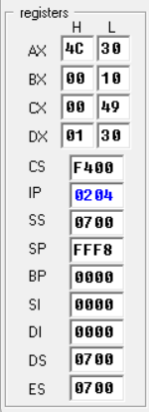

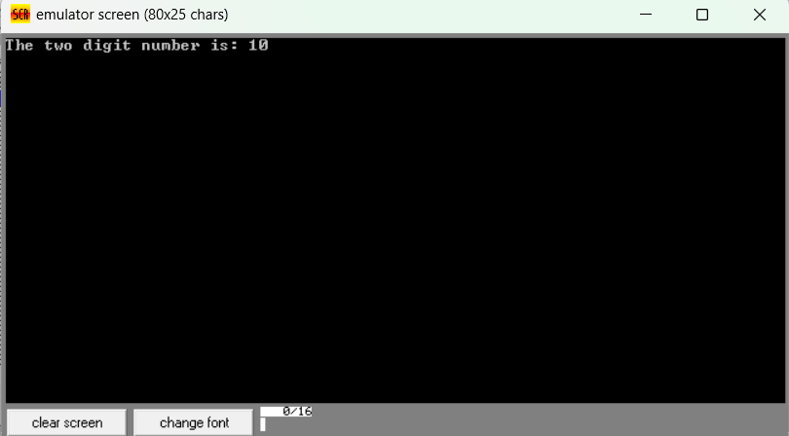

1. Write an assembly language program to take two single-digit integers from the user and

print the result of addition on the screen.

org 100h

mov dx,offset msg_input1

mov ah,09h

int 21h

mov ah,01h

int 21h

mov bl,al

cmp bl, '0'

jl notdigit

cmp bl, '9'

jg notdigit

sub bl,30h

mov dx,offset msg_input2

mov ah,09h

int 21h

mov ah,01h

int 21h

mov cl,al

cmp cl, '0'

jl notdigit

cmp cl, '9'

jg notdigit

sub cl,30h

add bl,cl

mov dx,offset msg_output

mov ah,09h

int 21h

mov al,bl

mov ah,00

mov bl,10

div bl

add al,30h

mov dl,al

mov bh,ah

mov ah,02h

int 21h

mov al,bh

add al,30h

mov dl,al

mov ah,02h

int 21h

jmp endprogram

notdigit:

mov dx, offset msg_error

mov ah, 09h

int 21h

msg_input1 db 'Enter integer1:$'

msg_input2 db 0ah,0dh,'Enter integer2:$'

msg_output db 0ah,0dh,'The sum is :$'

msg_error db 0ah, 0dh, 'Not a digit $'

endprogram:

mov ah,4Ch

int 21h

Output:

